**Helpful info**

* <http://www.cs.utexas.edu/~cannata/cs345/Class%20Notes/12%20prolog_intro.pdf>
* <http://www.gprolog.org/manual/gprolog.html>
* [web.stanford.edu/class/linguist138/Prolog_files/Prolog.ppt](http://web.stanford.edu/class/linguist138/Prolog_files/Prolog.ppt)
* [https://cse.sc.edu/~mgv/csce330sp06/prolog/PR1.ppt](https://cse.sc.edu/%7Emgv/csce330sp06/prolog/PR1.ppt)

**Where to get the language/Using the Environment**

You’ll need to connect to gem125 from a terminal window:

ssh –Y gem125.valpo.edu

We have GNU prolog … so

gprolog

is the tool to run.

***First Exercise***

* This is a warmup!
* Please find any prolog example out there, and demonstrate you can ask it questions. Please CITE/LINK where you got it, and explain why you picked it.

Test code:

child(john,sue). child(john,sam).

child(jane,sue). child(jane,sam).

child(sue,george). child(sue,gina).

male(john). male(sam). male(george).

female(sue). female(jane). female(june).

parent(Y,X) :- child(X,Y).

father(Y,X) :- child(X,Y), male(Y).

opp_sex(X,Y) :- male(X), female(Y).

opp_sex(Y,X) :- male(X), female(Y).

grand_father(X,Z) :- father(X,Y), parent(Y,Z).

Input:

female(sam).

female(june).

child(sue, jane).

child(jane, sue).

Output:

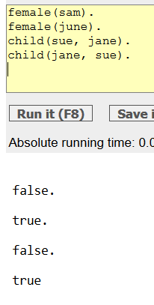

***Second Exercise***

* Take a look at <http://www.learnprolognow.org/slides/official/LPNchapter1.pdf>
* Build a (reasonable) prolog program along the same lines as the Pulp Fiction example based on the movie (or other story) of your choice [please note what you are using in your turn in, and please don’t get TOO obscure). It can be Winnie the Pooh, Disney, Hunt for Red October, Star Wars, whichever, whatever. It just needs to have a workable set of characters with connections you can reason on. Tip: the outer reaches of art film (or similar genres) probably won’t work well.

[Caveat: with families are fine but - since the rules are, shall we say, already available, you should have at least 4 generations to work with too keep things interesting.]

There should be at least 5 characters with at least 2 kinds of relationship, as a minimum.

* Demonstrate you can have Prolog process across at least 2 queries (as in, not hard coding) from your example.

Code:

sith(vader). sith(kylo). sith(maul). sith(sidious). sith(dooku).

jedi(obi-wan). jedi(rey). jedi(mace). jedi(aayla). jedi(luke).

skywalker(luke). skywalker(leia). skywalker(rey). skywalker(anakin).

blaster(han). blaster(chewbacca).

empire(stormtrooper).

empire(X):-sith(X).

rebels(X):-blaster(X); jedi(X).

enemy(X,Y):-rebels(X),empire(Y);rebels(Y),empire(X).

friend(X,Y):-rebels(X),rebels(Y);rebels(Y),rebels(X);empire(Y),empire(X);empire(X),empire(Y).

input:

jedi(han).

friend(maul, luke).

sith(vader).

jedi(vader).

enemy(luke, rey).

enemy(vader,luke).

Output:

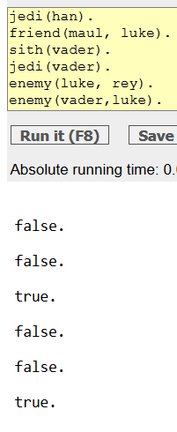

***Turning it in***

I would like a blackboard upload of your code and the screenshots. To speed up grading, please put the screenshots in a word processing (OpenOffice/Word or PDF; Word is preferred!) document; you may also put your code in there if you want, or you can upload it as text file(s).